Current Market View – May 2026

Investment Markets
Global Markets
Global markets in May 2026 were shaped by a steady but cautious risk-on tone as investors balanced resilient economic data against lingering inflation pressures and shifting central-bank expectations. Equity markets extended their early-year momentum, supported by another strong US earnings season, particularly across AI-linked sectors, while Europe and Japan benefited from improving manufacturing sentiment and a rebound in global trade flows. Energy prices eased from April highs, helping moderate headline inflation, yet core inflation remained sticky enough to keep rate cut expectations restrained. This produced a market environment where high-quality growth and technology continued to lead performance, while cyclicals saw selective buying tied to improving global demand indicators.
In fixed income, yields drifted higher as central banks signalled patience rather than urgency on policy easing, pressuring sovereign bonds but supporting credit markets where spreads tightened on solid corporate balance sheets. Emerging markets saw renewed inflows, helped by a softer US dollar and stabilising commodity prices, though geopolitical tensions kept volatility elevated. Overall, May 2026 reflected a market leaning toward optimism, anchored by AI earnings and improving global activity, yet still sensitive to inflation surprises and policy recalibration.

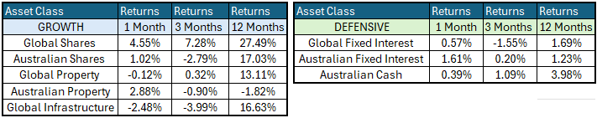

Global Share Markets
Global share markets continued rising in May after the brief sell-off in March when panicking investors sold down just about everything except for oil/gas stocks profiting from higher prices with the Strait of Hormuz closed. The stars in May were the US tech/ai giants, which were under-pinned by very good profit reports for the March quarter (Nvidia, Microsoft, Amazon, Alphabet/Google, Broadcom amongst others). Oil/gas stocks were down as oil prices fell back.
The US share market continued to surge – S&P500 up 5% for the month and posted 11 new all-time highs in May (making it 22 new all-time highs so far in 2026). However, it is not just a US boom. The best of the major markets outside of the United States has been Japan, led by Softbank (big Facebook holding plus other US tech bets), Keyence (robotics), and Shin-Etsu Chemical (plus assisted by a weaker yen). Next best was the US (tech/ai giants), and also Canada (oil/gold).
The local Australian share market continues to lag the rest of the world. It posted no new all-time highs in May. The All Ords was up just 1% in May led by most of the big miners were up (higher prices for iron ore, gas, coal), fossil fuel producers were down (oil prices down), and the rest of the market was generally down. The Federal Government 2026-27 Budget released mid month contributed to a relatively weaker ASX. The Budget provided for changes in capital gains tax and to negative gearing, as well as adding to structural spending which should see widening deficits in coming years.
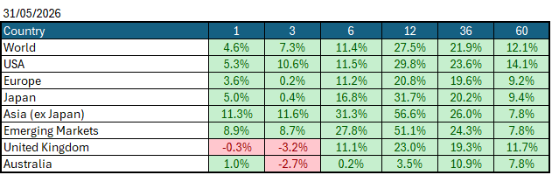
Data Source: AFM as of May 31, 2026.

Global Bond Markets
Bond yields rose for the first three weeks as the US/Iran see-saw led to fears of prolonged war. There was some excitement/panic when 30-year yields rose above 5%, the highest since 2007, but yields fell back as the Trump see-saw swung back towards another ‘deal’. Yields remain higher almost across the board for the year to date, as elevated fuel prices lift fears of even higher inflation and cash rates ahead.
Interest rate markets were mixed in May, with the US 10-year Government bond rate rising to 4.4541% and the UK 10-year Gilts falling to 5.048% from 5.283% in April 2026.
Domestic Bond Markets
Treasury yields fell across all maturities in Australia as markets started to decrease the number of interest rate hikes by the Reserve Bank this year. This was driven primarily by a weaker unemployment rate, which increased to 4.5% from 4.3%. For Australia, the latest inflation prints for (year-on-year) April 2026 decreased to 4.3%, up from 4.6% in March. The RBA board is set to meet on the 15th/16th June 2026, with the market half-pricing a +25bps rate hike to 4.60%.

Investment Climate
U.S. equities posted a strong performance in May 2026 as the earnings season benefited from strong results from the mega-cap AI infrastructure companies that posted strong revenue growth in cloud and datacenter segments. Semiconductor manufacturers extended their dominance as the backbone of the AI cycle, with record shipments of advanced GPUs and custom accelerators pushing margins higher and widening the gap between leading-edge and legacy chipmakers. Software and platform companies also benefited, reporting accelerating adoption of AI-enhanced productivity tools and subscription upgrades that lifted recurring revenue.
Over the medium term, investors are encouraged by the anticipated productivity benefits from AI and the hyperscalers' investments in AI. However, with the unsettled nature of the bond markets due to the war in Iran, the short term has put the handbrake on the level of encouragement. If the US changes its tone and begins raising interest rates under its new Federal Chairman, Kevin Warsh, the medium term could become much less encouraging.
Long-term investors are cautiously optimistic about a recovery period ahead. Global central banks continue to indicate a resolve to get inflation under control; however, economic data is showing signs of stabilisation despite elevated inflation, which could lead central banks to increase interest rates in 2026.
The following commentary is based on month-end closing prices as of May 31, 2026:
Global share markets were all stronger in May outside of the UK, driven by investors believing that geopolitical events in the Middle East will come to an end shortly, with the US and Asian markets outperforming Europe and the United Kingdom, which has less access to AI technology companies. The AUD/USD marginally weakened from 0.7201 to 0.7184 (-0.2%).
The U.S. Fed held the federal funds rate target range at 3.50%-3.75% when it met on the 28th/29th April 2026. Last month, the rhetoric of a soft landing came under pressure amid the expected increase in inflation following the oil price spike, which has brought the chances of a rate hike in the US back to the table. The next Fed meeting is on the 16th/17th June 2026.
The underlying short-term theme is "cautious" for shares.
The situation in the Russia/Ukraine conflict remains unchanged, with the latest conflict between Israel and Gaza (Hamas) remaining unchanged as well. Volatility and risk increased as the USA/Israel moved towards a war with Iran.
Investor Focus
For Australia, investors focused on the following issues:
- Cost of living expenses and the impact on consumer spending.
- Commodity prices (post-China policy changes) and the impact on company profits.
- The level of interest rates and the delicate position of the RBA, given the global volatility in markets.
- Rising Oil Prices as conflicts with Iran escalated
- U.S. tariffs and the impact on Australia's exports (if any).
- Inflation (year-over-year) increased to 4.6% in the March quarter, with the next quarterly CPI being released on July 29, 2026.
- Government spending and the rising debt level.

Currency
The Australian Dollar closed marginally weaker, AUD/USD 0.7184 at the end of May 2026, down from 0.72 in April. As the Aussie dollar is a 'risk currency', it always sells off in a global crisis, as we saw in March, regardless of local conditions. In March, it fell against all major currencies, especially the US dollar. April and May saw a reversal of this as investors became less worried about the war in Iran, leading to the AUD strengthening against most other currencies. The US is the global 'safe haven' currency (and has been since WW1), and so it (almost) always rises in global crises, even if the US is the cause of the panic (for example, in the GFC). But in April and May, we saw an unwind of that mentality with the USD weakening against most currencies.

Currency forecasters see the AUD/USD range between:
0.65 and 0.75 cents in the medium term and most likely to trade within the:
0.5500 to 0.7500 range in the longer term.

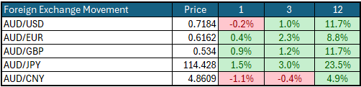

Australian Economy
Australia's latest GDP data for the final quarter of 2025 showed an annual growth rate of 2.6%, up from 2.1% in the third quarter of 2025. Unemployment increased marginally in March to 4.3%, up from 4.2% in February 2026. The year-over-year (Y-O-Y) inflation rate decreased to 4.2%, down from 4.6% in April 2026, but remains outside the Reserve Bank's targeted 2% to 3% inflation range and will potentially lead to another rate hike later this year.

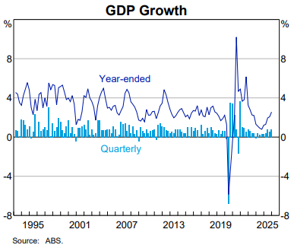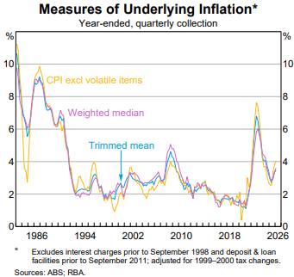

Current Market View

Domestic View
The overall investment view for shares is "cautious" over the short term, "cautiously optimistic" over the medium term, and "long run" as corporate profits continue to grow faster than inflation and as the need to build out data centres drives commodity prices higher.
The market is currently pricing in a half an interest rate hike on the 15th/16th of June 2026, due to a "hotter" inflation print in May that showed inflation is now outside the RBA's target range of 2-3%, in combination with increases in the oil price to increase inflation over the short-term.

Global View
The global share market remains cautious, aside from a few AI companies, amid the looming threat of a global inflation spike that could force many economies to raise interest rates. Given the current tensions in the Middle East, we could see a global slowdown in GDP, as energy production cannot keep up with the rollout of AI data centres.

Where to From Here?
- Continued shift from rules-based order and win-win multilateral trade to power-based order and win-lose trade deals. Trump did not start this. The shift started in the 2010s with the U.S./Europe letting Putin take Crimea in return for cheap gas for Germany/Europe, and the U.S./Japan letting China militarise the South China Sea. It has certainly accelerated under Trump. Lower cross-border trade & investment, more reliance on government subsidies & distortions, and inflationary onshoring of uneconomic industries.
- Sticky inflation - political pressure on central banks to keep rates low – populist pressure on governments to keep deficit spending. Tariffs + onshoring are adding to costs/prices. Bond yields to stay elevated or even drift higher, risk of bond yield spikes, or a sudden need for rate hikes, unsettling / breaking share markets.
- Share markets continue to be supported by good profit growth for now. Shares everywhere are expensive, but buoyed by loose monetary & fiscal policies, plus a near-certainty that governments will throw 'free'/borrowed money at any problem.
- Commodities rally gathering pace – rising demand soaking up oversupply, AI/data centre boom (industrial metals, energy, water, land), global rearmament – especially Europe, Japan, Canada. This should support the ASX market, as long as banks avoid a local recession.
- De-dollarisation fears are probably overdone, but are driving up gold and silver, not bitcoin. U.S. Treasury yields are not at risk for now.
- The current boom will end one day, of course. All markets everywhere, including and especially Australia, are overpriced on fundamentals, not just U.S. big tech. However, each boom is different, and the triggers for the inevitable bust are different each time.

This document is issued by Atlas Funds Management Pty Ltd. Atlas Funds Management Pty Ltd does not provide any general advice or personal advice regarding any potential investment in any financial products within the meaning of section 766B of the Corporations Act. No consideration has been made of any specific person's investment objectives, financial situation or needs. The provision of this presentation is not and should not be considered as a recommendation in relation to an investment in any entity or that an investment in any entity is a suitable investment for any specific person. Recipients should make their own enquiries and evaluations they consider appropriate to determine the suitability of any investment (including their investment objectives, financial situation, and particular needs) and should seek all necessary financial, legal, tax and investment advice. Atlas Funds Management Pty Ltd, it's directors and employees do not accept any liability for the results of any actions taken or not taken on the basis of information in this presentation, or for any negligent misstatements, errors or omissions. This presentation is not an advertisement and is not intended for public use or distribution. Past performance of a fund is no guarantee of its future performance.

